**Exercise 9: Creating a Spring Boot Application**

Go to start.spring.io

Project: Maven Project

Language: Java

Spring **Boot Version**: 3.5.3

Group: com.library

Artefact: exercise9

Name: exercise9

Description: Library Management System

Package **Name**: com.library

Packaging: Jar

Java: 24

Include the Spring Web, Spring Data JPA and H2 Database.

Configure, application.properties

# H2 Database Configuration

spring.datasource.url=jdbc:h2:mem:testdb

spring.datasource.driverClassName=org.h2.Driver

spring.datasource.username=sa

spring.datasource.password=password

spring.jpa.database-platform=org.hibernate.dialect.H2Dialect

# JPA Hibernate Configuration

spring.jpa.hibernate.ddl-auto=update

spring.jpa.show-sql=true

# Enable console for H2 (to check data through a browser)

spring.h2.console.enabled=true

# Server configuration (optional)

server.port=8080

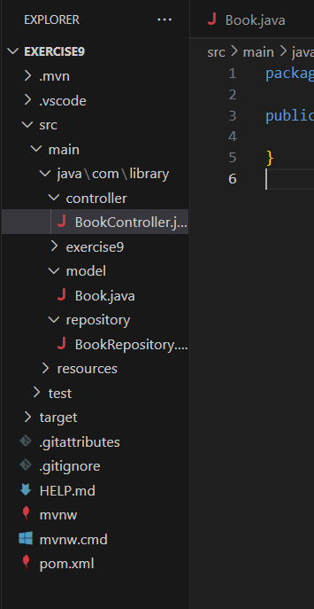

Book.java

package com.library.model;

public class Book {

}

BookRepository.java

package com.library.repository;

import com.library.model.Book;

import org.springframework.data.jpa.repository.JpaRepository;

public interface BookRepository extends JpaRepository<Book, Long> {

}

BookController.java

package com.library.controller;

public class BookController {

}